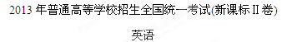
第一部分 英语知识运用(共两节，满分45分)
- 单项填空(共15小题:每小题1分，满分15分)
从A、B、C、D四个选项中选出可以填入空白处的最佳选项，并在答题卡上将该选项涂黑。
例:It is generally considered unwise to give a child he or she wants.
A. however B. whatever C. whichever D. whenever
答案是B。
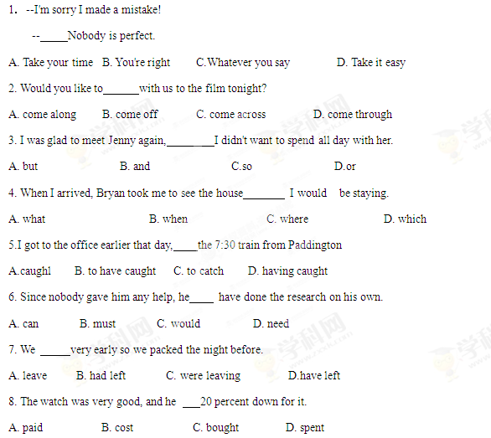
9. It may not be a great suggestion. But before _______ is put forward, we’ll make do with it.
A. a good one B. a better one C. the best one D. a best one
10. It was only after he had read the papers Mr. Gross realized the task before him was extremely difficult to complete.
A. when B. that C. which D. what
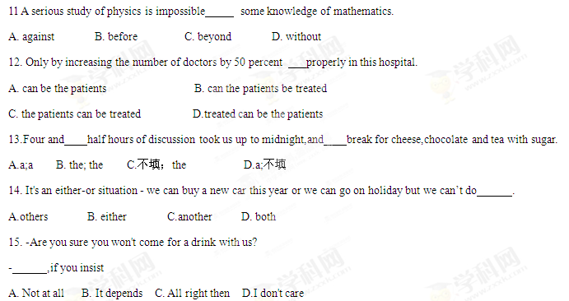第二节 完形填空（共20小题；每小题1.5分，满分30分）
阅读下面短文，从短文后面各题锁哥的四个选项(A、 B、C 和 D)中选出可以填入空白处的最佳选项，并在答题卡上将该项涂黑。
Michael Greenberg is a very popular New Yorker. He is not famous in sports or the arts, But people in the streets 16 him, especially those who are 17 .
For those people, he is "Gloves" Greenberg. How did he get that 18 ?
He looks like any otner businessman, wearing a suit and carrying a briefcase (公文箱). But he's 19 _. His briefcase always has some gloves。
In winter,Mr.Greenberg does not 20 like other New Yorkers,who look at the sidewalk and 21 the street.He looks around at 22 .He stops when he 23 someone with no gloves.He gives them a pair and then he 24 ,looking for more people with cold 25 .
On winter days,Mr.Greenberg 26 gloves.During the rest of the year,he 27 gloves.People who have heard about him 28 him gloves,and he has many in his apartment.
Mr. Greenberg 29 doing this 21 years ago. Now, many poor New Yorkers know him and 30 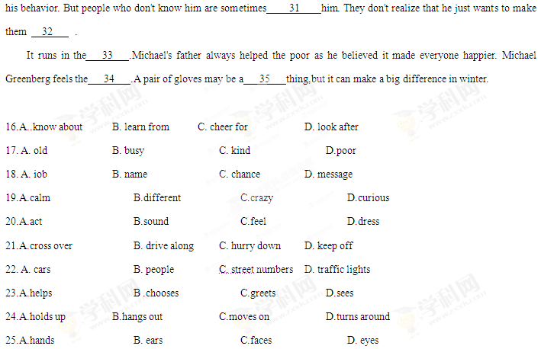 26. A. searches for B. stores up C.gives away D. puts on
27. A. borrows B. sells C.returns D. buys
28. A. call B. send C. lend D. show
29. A. delayed B. remembered C. began D. enjoyed
30.A.understand B.dislike C.study D.excuse
31.A.sorry for B.satisfied with C.proud of D.surprised by
32.A.smart B.rich C.special D.happy
33.A.city B.family C.neighborhood D.company
34.A.honor B.pain C.same D.cold
35.A.small B.useful C.delightful Dcomforting

第二部分阅读理解(共两节，满分40分》
第一节(共15小题:每小题2分，满分30分)

阅读下列短文，从每题所给的四个选项《A、 B、 C和D)中。选出最佳选项，并在答题卡上将该项涂黑。
A
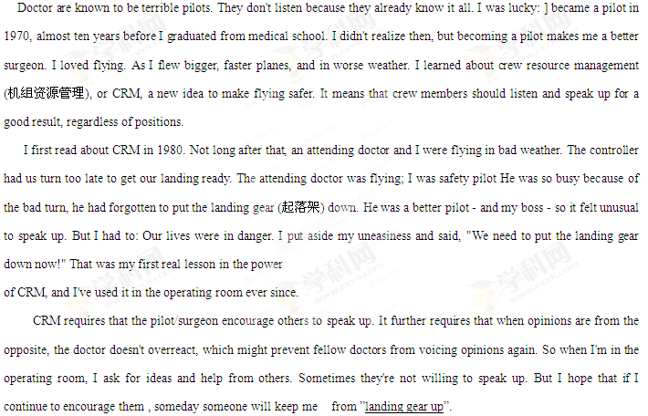36.What dose the author say about doctors in general?
A. They like flying by themselves.
B. They are unwilling to take advice.
C. They pretend to be good pilots.
D. They are quick learners of CRM.
37.The author deepened his understanding of the power of CRM when_______.
A. he saved the plane by speaking up
B. he was in charge of a flying task
C. his boss landed the plane too late
D. his boss operated on a patient
38.In the last paragraph”landing gear up” probably means ______.
A.following flying requirements.
B.overreacting to different opinions.
C.listening to what fellow doctors say
D.making a mistake that may cost lives
39.Which of the following can be the best title for the text?
A.CRM:A New Way to Make Flying Safe
B.Flying Makes Me a Better Doctor
C.The Making of a Good Pilot
D.A Pilot-Tumed Doctor

B
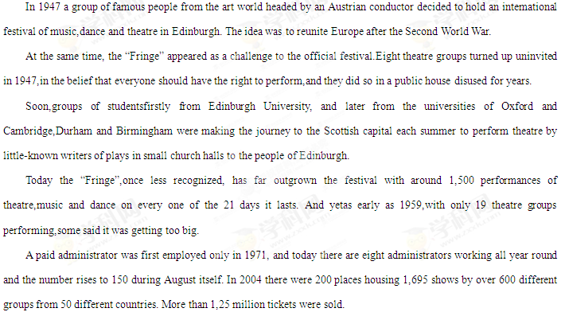40. Point was the purpose of Edinburgh Festival at he beginning?
A. To bring Europe together again.
B. To honor heroes of World War 11.
C. To introduce young theatre groups.
D. To attract great artists from Europe.
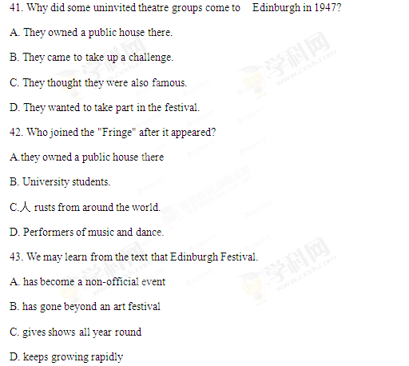 C
Given that many people's moods (情绪)are regulated by the chemical action of chocolate, it was probably only a matter of time before somebody made the chocolate shop similar to a drugstore of Chinese medicine. Looking like a setting from the film Charlie&the Chocolate Factory, Singapore's Chocolate Research Facility (CRF) has over 100 varieties of chocolates.its founder is Chris Lee who grew up at his parents' comer store with one handalmost always in the jar of sweets.
If the CRF seems to be a smart idea, that's because Lee is not merely a seasoned salesperson but also head of a marketing department that has business relations with big names such as Levi's and Sony. That idea surely results in the imagination at work when it comes to making different flavored(味道)chocolates.
The CRF's produce is "green". made within the country and divided into 10 lines, with the Alcohol Series being the most popular. The Exotic Series一with Sichuan pepper, red bean (豆).cheese and other flavors一also does well and is fun to taste. And for chocolate snobs，who think that they have a better knowledge of chocolate than others, the Connoisseur Series uses cocoa beans from Togo, Cuba, Venezuela , and Ghana, among others.

44. What is good about chocolate?
A. It serves as a suitable gift.
B. It works as an effective medicine.
C. It helps improve the state of mind.
D. It strengthens business relations.

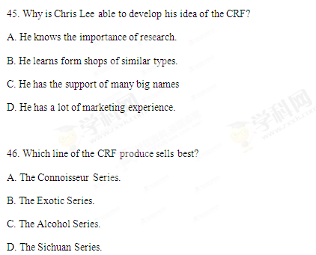

47. The words "chocolate snobs" in Paragraph 3 probably refer to people who
A. are particular about chocolate
B. know little about cocoa beans
C. look down upon others
D. like to try new flavors

D
Low-Cost Gifts for Mother's Day
Gift No. I
Offer to be your mother's health friend. Promise to be there for any and all doctor's visits
whether a disease or a regular medical check-up. Most mothers always say "no need," another set of eyes and ears is always a good idea at a doctor's visit. The best part ? This one is free.

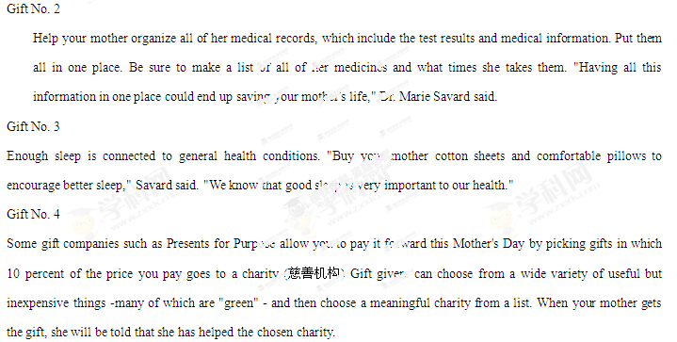48. What are you advised to do for your mother at doctor's visits?
A. Take notes.
B. Be with her.
C. Buy medicine.
D. Give her gifts.
49. Where can you find a gift idea to improve your mother’s sleep?
A. In Gift No. 1. B. In Gift No. 2.
C. In Gift No. 3. D. In Gift No. 4.
50. Buying gifts from Presents for Purpose allows mothers to
A. enjoy good sleep B. be well-organized
C. bet extra support D. give others help
第二节（共5小题；每小题2分，满分10分）
根据根据短文内容，从短文后的选项中选出能坡入空白处的最佳选项。选项中有两项为多于选项。
Public Speaking Training
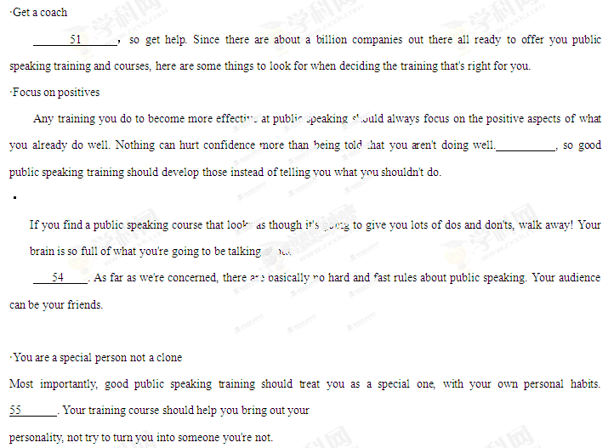A. You aren't like anybody else
B. You already do lots of things well
C. Turn your back on too many rules
D. Check the rules about dos and don'ts
E. Whatever the presentation, public speaking is tough
F .The one thing you don't want is for them to fall asleep
G. So trying to force a whole set of rules into it will just make things worse
2013年普通高等学校招生全国统一考试
英 语
第Ⅱ卷
第三部分 写作（共两页，满分35分）
第一节 短文改错（共10小题；每小题1分，满分10分）
假定英语课上老师要求同桌之间交换修改作文，请你修改你同桌写的以下作文。文中共有10处语言错误，每句中最多有两处，每处错误仅涉及一个单词的增加、删除或修改。
增加：把缺词处加一个漏符号（∧），并在其下面写出该加的词。
删除：把多余的词用斜线（\）划掉。
修改：在错的词下划一横线，并在该词下面写出修改后的词。

注意：1. 每处错误及其修改均仅限一词；
2. 只允许修改10处，多者（从第11处起）不计分。
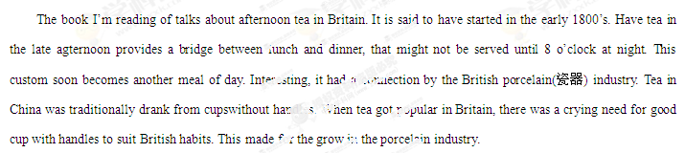第二节 书面表达（满分25分）
假定你是李华，自制一些中国结（Chinese knot）。给开网店的美国朋友Tom写封信，请他代卖，要点包括：
1.外观（尺寸、颜色、材料）
2.象征意义
3.价格
注意：1.词数100左右；
2.可以适当增加细节，以使行文连贯；
3.开头语已为你写好。

